Applicability of data distribution technologies within ITS

# Scope

A variety of general-purpose data distribution technologies have emerged within the Information and Communications Technologies (ICT) industry. These technologies generally provide services at the Open System Interconnect (OSI) Session, Presentation, and Application Layers (i.e., Layers 5-7). Within Intelligent Transport Systems (ITS), these layers roughly correspond to the Facilities Layer of the ITS station architecture, as defined within ISO 21217.

This Technical Report investigates the applicability of these data distribution technologies within the ITS environment.

# Normative references

# Terms and definitions

facilities layer

ITS station architecture

# Symbols and abbreviations

ICT

ITS

OSI

# Transitioning from traditional to cooperative thinking

## General

ITS is heavily dependent upon the exchange of varied types of data between and among disparate types of physical objects. Physical objects include:

* Centres (e.g., fixed-location facilities and cloud-based back-office services)
* Field devices (e.g., devices along the roadside)
* Vehicles
* Travelers (e.g., personal devices)
* Support systems (typically fixed or back-office, that provide services enabling ITS, but do not directly provide ITS services)

The data that these systems exchange include:

* Live elemental data (e.g., vehicle speed, location, signal timing information, etc.)
* Live aggregated data (e.g., average speeds, rain rates, etc.)
* Status information (e.g., status of reversible flow lanes)
* (Relatively) static data (e.g., map information)
* Exceptional reports (e.g., information on traffic incidents, realignment of lanes due to incidents or road work, etc.)
* Configuration data (e.g., certificate revocation lists, traffic regulation information, software configuration, etc.)
* Coordination data (e.g., exchanges to coordinate a response plan among centres)
* Traffic regulations
* Software updates (e.g., for on-board applications)
* Security certificate and revocation list distribution

The varied data exchanges among the different physical objects also has various needs for data distribution. For example, software updates might be intended for specific vehicles. Traffic regulation data is likely intended for all vehicles within a jurisdiction. Exceptional reports might be intended for vehicles approaching an incident. And finally, there is an increasing appreciation that some of the information exchanged might be useful to support ITS services other than the ITS service for which the data was originally intended.

There are a variety of technical and institutional challenges in successfully sharing data in a timely and secure manner. Challenges include:

1. Acquiring the data (e.g., through sensors)
2. Defining ownership and access rights for the data
3. Securing the data (e.g., authentication, authorization, confidentiality, integrity, availability, etc.)
4. Achieving adequate market penetration of lower-layer communication technologies
5. Agreeing on the upper-layer protocols for exchanging the data over the communication technologies
6. Standardizing the definition of data for use in various contexts
7. Defining performance criteria for different uses of the data
8. Maintaining the interface over the life cycle of the involved physical objects. Operational lifetimes for ITS devices vary radically; field devices often have lifetimes of 15-20 years, vehicles closer to 10 (though often much longer), and smartphones merely 18-24 months.

This technical report focuses on the upper-layer protocols (i.e., item 5) while recognizing that this layer will need to provide adequate services to support the other issues. For example, part of our analysis of the data distribution technologies considers the ability of each technology to provide authentication services that meet rigorous ITS demands as well as an analysis of the performance implications of each technology (e.g., processing and bandwidth requirements). Other issues listed are largely left to other stakeholders in the ITS community.

## Systems engineering process

The systems engineering approach to designing any complex system is to work with the relevant stakeholders, including service providers and system integrators, to develop a “Concept of Operations”, or ConOps. This involves describing in detail the service (the “why”), the actors participating in the service (the “who”), and the requirements on information that must be generated and exchanged by entities engaged in the service (the “what”).

Once agreement is reached on the ConOps, the implementers work together to develop a high-level design (i.e., an architecture) that defines the means by which the service will be implemented (the “how”), which must (directly or indirectly) define the details of how the information is encoded and transferred between physical objects. If the system is intended to support an open interface (i.e., so that competing manufacturers can interoperate); these design details should be defined within open standards and developed with broad-based consensus.

## Traditional silos versus cooperative approach

Once the architecture is developed, each interface is designed by its own group of experts to meet the defined needs. However, this division of effort tends to produce “silos” of thought that can often result in four major problems:

1. **Competing protocol selection:** Different silo efforts are likely to select different approaches to exchanging data. There are many off-the-shelf protocols that can be extended to support most ITS data exchange needs and some experts may wish to develop their own protocols to optimize performance in certain cases. While each decision may be reasonable in isolation, each protocol adopted by the ITS industry has costs associated with stakeholders learning the technology, implementers programming with the technology, testers verifying conformance to the technology, and maintenance issues with maintaining backwards compatibility, as well as memory and processing issues within devices that have to support multiple technologies. Ideally, the ITS community as a whole should attempt to identify a suite of preferred protocols that meet industry needs so that the variability in systems is minimized.
2. **Competing data definitions:** Different silo efforts are likely to produce different data definitions to describe the same real-world conditions. This greatly complicates data sharing, increases potential translation errors, and increases integration costs. Ideally, all ITS data definitions should be developed in a cooperative fashion.
3. **Limited scope and lack of forwards compatibility:** Engineers within the silo teams will often attempt to “optimize” their design; however, without a complete knowledge of how data might be used, it is impossible to know if a design is truly optimal or not. This can partially be overcome by ensuring that the reference architecture is developed with a broad as scope as practical, but since innovations occur over time, it must be understood that no effort will ever be omniscient about how the data might be used; we can only attempt to consider as much data as possible.
4. **Competing efforts:** A final challenge facing any development team is that there is often different competing and/or overlapping efforts across the world. Once standards are developed, it is often difficult and expensive to harmonize the results after the fact.

This technical report attempts to address the first issue by identifying different protocols that have been suggested for use within the ITS industry, comparing their respective characteristics, and suggesting a preferred set of protocols for future use.

## Summary of needs ad considerations

In order to evaluate specific technologies, the analysis began by identifying the key stakeholder needs and considerations for data distribution. These were then organized into a structure that can be used to compare various technologies in a consistent manner. The needs and considerations identified are described in the following subsections.

### Architectural topology

Part of the goal in sharing data among systems is to minimize the complexity associated with maintaining connections between the various components. Each data distribution technology is based on a architectural topology that can generally be grouped into one of four styles as described below.

#### Mesh Topology

Within a mesh topology, every application entity is required to establish a connection with every other application entity with which it wants to communicate. Once a connection is established, the two applications can subscribe for information and provide publications as necessary.

The mesh topology is depicted in Figure 1.

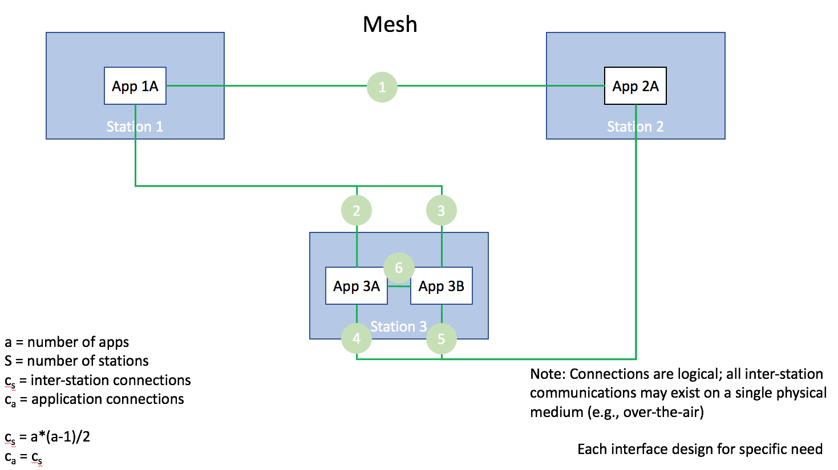

Figure 1: Mesh topology

The mesh topology has the advantage that an application providing data can ensure that the application requesting the data is authorized to receive it; but this also means that each application has to spend resources managing connections and authorizing requests. This can be especially challenging in a cooperative environment where requesters are not necessarily part of a pre-defined list and the number of connections are not necessarily constrained.

#### Hub-and-spoke topology

Within a hub-and-spoke topology, every spoke application entity is required to establish a connection with a hub application. The spoke can then subscribe for information or publish information to the hub. The hub then has the responsibility of forwarding the publications to all applications that have subscribed for the data.

The hub-and-spoke topology is depicted in Figure 2.

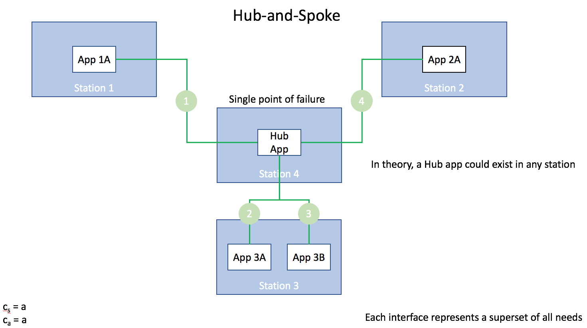

Figure 2: Hub-and-spoke topology

The hub-and-spoke topology has the advantage that an application providing data can focus on providing its core service while managing a single connection; however, it delegates the authorization task to a remote hub application, which potentially raises issues in a C-ITS environment where the hub application is a separate system (i.e., owned and/or operated by a different legal entity and therefore increasing the number of legal entities with theoretical access to the data). The design also presents challenges for a constantly changing network where devices are mobile and are constantly connecting and disconnecting.

#### Peer-to-peer topology

Within a peer-to-peer topology, every device supports its own service that acts in a manner similar to a hub. Each application within each device connects to its local hub service. The hub service then connects to the hub services in other devices. Applications publish information to their local hub; the hub service then takes care of distributing the information to other local entities and remote hub services that are authorized.

The peer-to-peer topology is depicted in Figure 3.

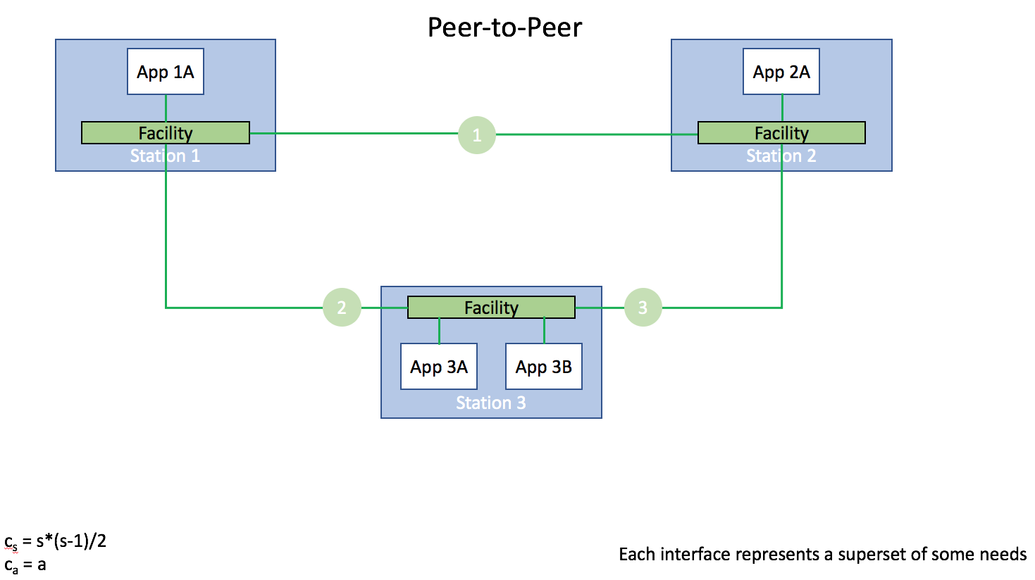

Figure 3: Peer-to-peer topology

The peer-to-peer topology has the advantage that an application providing data can focus on providing its core service while managing a single connection; further, the authorization task is still largely controlled by a local service within the same system. While a portion of the authorization task is the responsibility of the remote hub service, data will only be sent to the remote service if the remote service (and hence that system) has authorization. The biggest challenge for this design in in maintaining connections in the mobile devices, but this is less of a problem than in some other designs since there are fewer connections to maintain and the management of these connections are concentrated in dedicated software.

#### Hierarchical hub topology

The hierarchical hub topology combines the concepts of the hub-and-spoke and peer-to-peer topology. Every device supports its own service that acts in a manner similar to a hub; and the various devices also connect via a device hub. Each application within each device connects to its local hub service. The hub service then connects to a central device hub. Applications publish information to their local hub; the local hub service then takes care of distributes information to the device hub, if authorized. The device hub then distributes to end applications via their own local hubs.

The hierarchical hub topology is depicted in Figure 4.

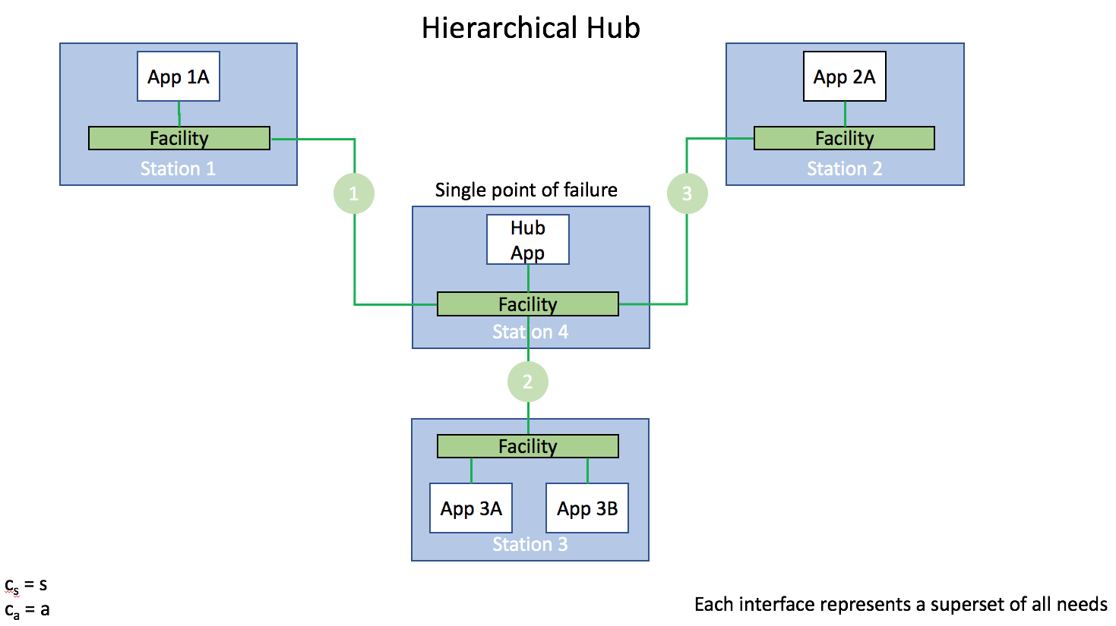

Figure 4: Hierarchical hub topology

The hierarchical hub topology has many of the advantages of both the hub-and-spoke and peer-to-peer topologies.

#### Summary of topologies

The various advantages and disadvantages of each topology are summarized in Table 1.

|  |  |  |  |  |
| --- | --- | --- | --- | --- |
| Characteristic | Mesh | Hub-and-spoke | Peer-to-peer | Hierarchical hub |
|  |  |  |  |  |
|  |  |  |  |  |
|  |  |  |  |  |
|  |  |  |  |  |